- Order
- A tentative answer to a question
- My phone isn’t turning on because the battery needs to be charged
- Why does ice cream cause me to get stomach aches
- Count the number of times my baby smiles after sleeping for different amount of times
- Does listening to music while listening affect the exam score?
- Group B
- The results of the study do NOT support the hypothesis
- Carbon, hydrogen, oxygen, nitrogen
- 23 amu
- The second and third electron shells can hold up to 8 electrons each
- In a covalent the partners share electrons; in an ionic bond one partner accepts electrons from another.
- 4
- 2 pairs of electrons
- It has areas with slight charges
- Covalent, hydrogen
- Cohesion is related to hydrogen bonding
- An increase in H⁺ concentration leads to a decrease in the P^{H}
- Keeps the P^{H} relatively stable
- They are hydrophilic
- Functional groups give molecules specific properties
- Dehydration
- Monosaccharides
- Glycogen; starch
- Fats are mostly made of carbon and hydrogen which are non-polar.
- Enzymes
- Peptide bonds
- All of the answers are true
- Information storage
- Nucleotide
- Acid; neutral
- Polar; non polar
- Electron, Neutron, Proton, Electron
- Lipid, Nucleic acid, Carbohydrate, Protein

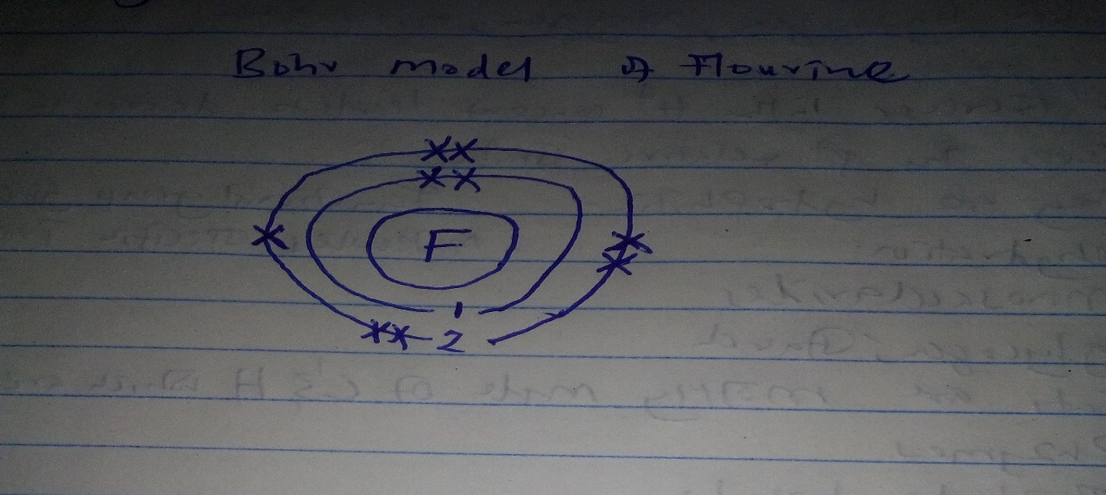
- Testosterone is a steroid hormone which implies that it is derived from lipids. /// Testosterone is hydrophobic as it is able to diffuse through the cell membrane.
- A. It exhibits irritability- the ability to respond to touch stimuli // It is able to undergo development through software upgrades
B. It does not reproduce
It does not regulate internal conditions constant through the process of homeostasis
- A. Water molecule is polar in nature. It has partial positive charges on the hydrogen atom and partial negative charges on the two oxygen atoms.
B. The water molecule form hydrogen bonds among different molecules. There is a partial negative charge on the oxygen atom of one molecule can form a hydrogen bond with the partial positive charge on the hydrogens.
C. Since water molecules are also attracted to other polar water molecules and to ions, this makes it possible for ice to float.

